Hello World RESTful Web Service
🔹 Project: spring-learn
🔹 Endpoint URL: http://localhost:8083/hello

🔹 Added Spring Boot Web Dependency
The following dependency was added in the pom.xml to enable RESTful services:

<dependency>
<groupId>org.springframework.boot</groupId>
<artifactId>spring-boot-starter-web</artifactId>
</dependency>

Spring Boot Configuration
In application.properties, the following property was added to set the custom port:

server.port=8083

🔹 Controller Class:

package com.cognizant.spring_learn.controller;

import org.slf4j.Logger;
import org.slf4j.LoggerFactory;
import org.springframework.web.bind.annotation.GetMapping;
import org.springframework.web.bind.annotation.RestController;

@RestController
public class HelloController {

private static final Logger LOGGER = LoggerFactory.getLogger(HelloController.class);

@GetMapping("/hello")
public String sayHello() {
LOGGER.info("START - sayHello");
LOGGER.info("END - sayHello");
return "Hello World!!";
}
}

🔹 Output
- ✅ Accessed the URL: http://localhost:8083/hello
- ✅ Response in browser and Postman:

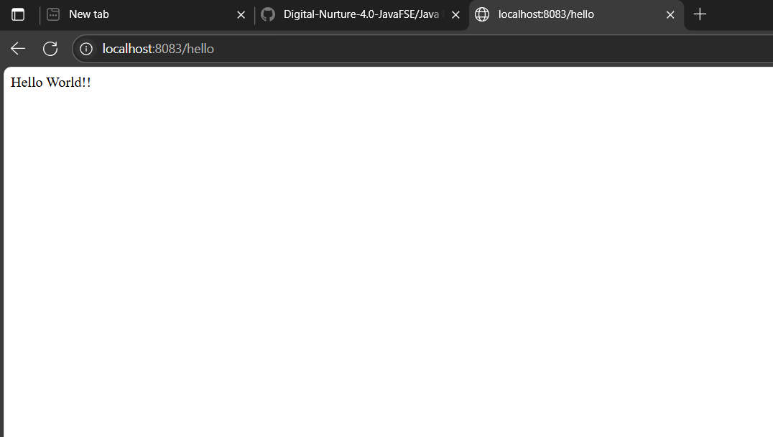

- ✅ Console Output:

